34.72: 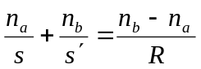 and taking its derivative with respect to s we have:
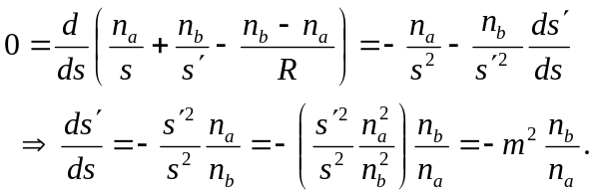
But 